Computer Language Coding Concepts

Identifiers in a Diagram
Identifiers are names for objects, collections, attributes, sites, programs, modules or any other element of a system. Any element of a system can get an identifier.

Identifiers are explained in the article Identifiers. This article demonstrates their usage in a diagram.

An identifier is placed just outside a shape’s border, usually just above it.
Any shape can get an identifier.

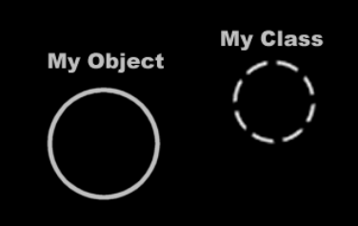

Identifiers are also put at the end of lines that direct out of the diagram, to identify the target of the line.

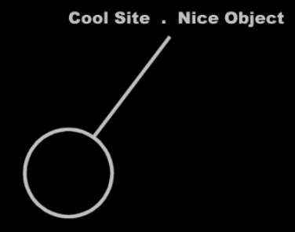

See also: Identifiers.

Author & Copyright: Jan-Joost van Zon Date: May 21, 2008 – May 22, 2008 Location: Oosterhout, The Netherlands Status: Finished

